1 ) Create user with name Techie and provide sudo access to user. ?

Useradd username

vi /etc/sudoers - to provide access to any user in sudoers

2) Navigate to the home directory.

Cd ~

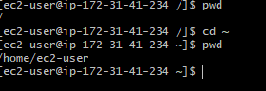

3) Create a new directory.

Mkdir name

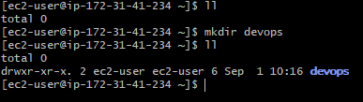

4) List the contents of a directory.

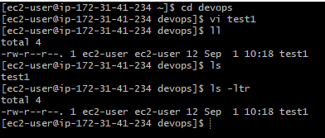

5) Change the current directory.

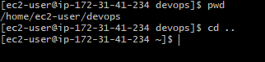

6) Create a new empty file.

touch filename

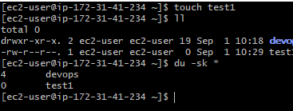

7) View the contents of a file.

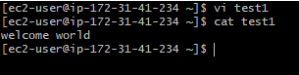

8) Copy a file to another location.

Cp filename destination path

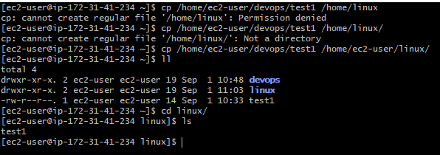

9 ) Move a file to another location.

mv filename destination path

10) Rename a file

mv filename newname

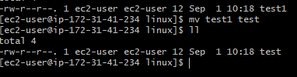

11) Delete a file.

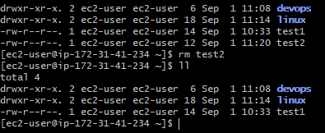

12) Grant or revoke permissions on a file or directory.

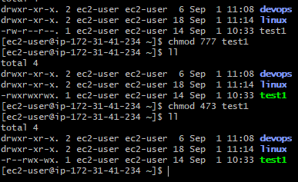

13) View the current date and time.



14) Check the system uptime.

Uptime

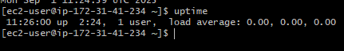

15) View the running processes.

ps -ef

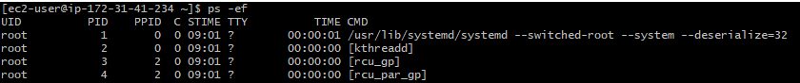

16) Kill a running process.

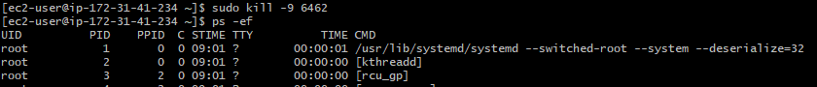

17) Install a package using the package manager (e.g., apt or yum).

Sudo yum install nginx

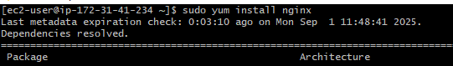

18) Update the system packages.

Sudo yum upgrade –y or sudo yum update -y

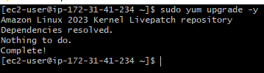

19) Create a symbolic link.

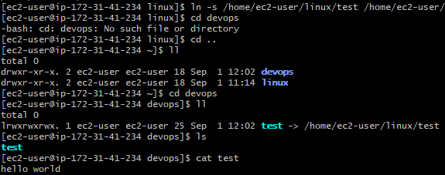

20) Search for files using the find command.

Sudo find / -type f –name “filesname”



21) Compress and decompress files using tar.

Tar cvf newname.tar filename

Tar xvf newname.tar

22) Monitor system resources with top or htop.

To check system resources – top

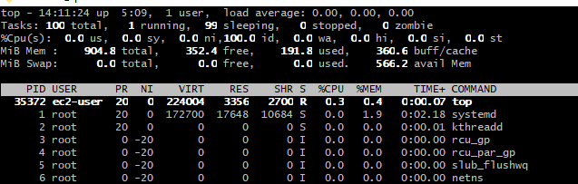

23) Create and manage user groups.

sudo groupadd developers (group name) : create a new group



groups devops(username) : to view user from group

sudo usermod -aG developers (group name) devops (username) : add a user to group

cat /etc/group : to view all groups in the system

grep '^developers:' /etc/group : to check or view particular group

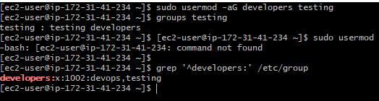

24) Set up SSH password less authentication.

25) Monitor log files using tail or grep.

Tail –f filename

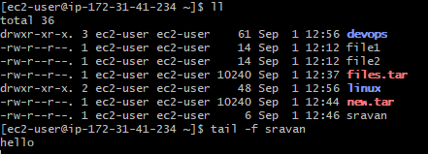

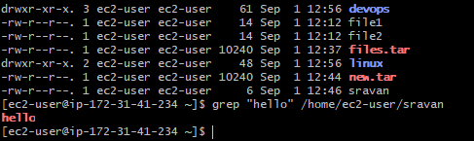

26) Set up a web server (e.g., Apache or Nginx).

Sudo yum update -y

sudo yum install nginx -y

sudo systemctl enable nginx

sudo systemctl start nginx

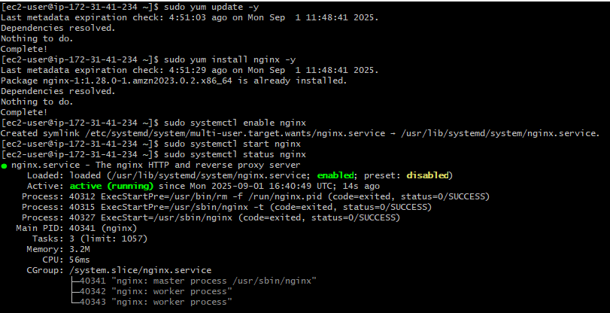

27) Configure and secure a MySQL Database.

Download & Import MySQL GPG Key :

sudo rpm --import <https://repo.mysql.com/RPM-GPG-KEY-mysql-2023>

Install the MySQL Yum Repo:

sudo dnf install -y <https://dev.mysql.com/get/mysql80-community-release-el9-1.noarch.rpm>

Install MySQL Server:

sudo dnf install -y mysql-community-server

30) Print specific columns from a delimited file.

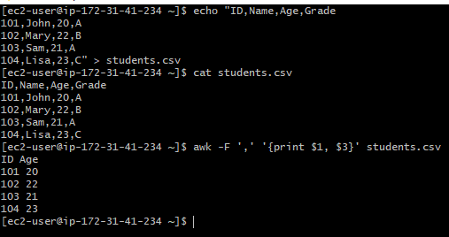

31) Filter and print lines based on a specific pattern or condition.

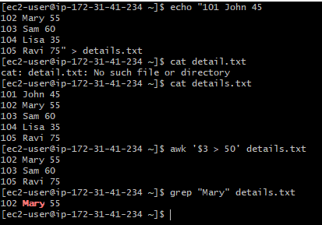

32) Calculate and print the average, sum, or other statistics of a column.

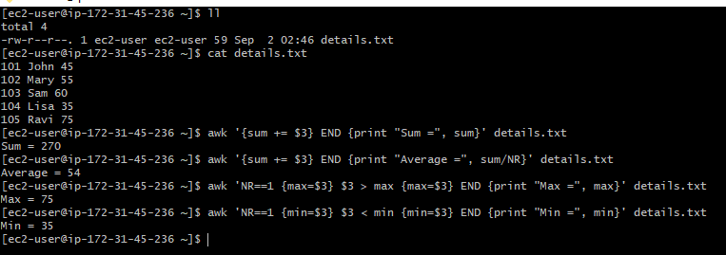

33) Perform string manipulation, such as extracting substrings or changing case.

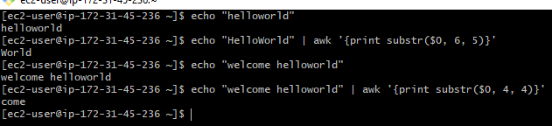



34) Count the occurrences of a specific pattern in a file.

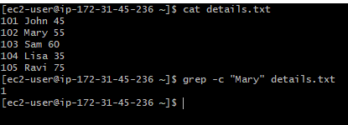

35) Sort lines based on a specific field or column.

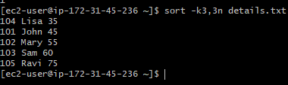

36) Merge multiple files based on a common field or column

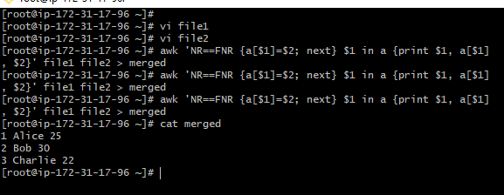

37 Substitute text in a file using search and replace.

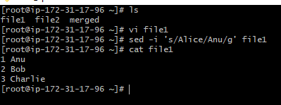

 38 Delete specific lines based on a pattern or line number.

Example: file1

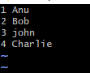

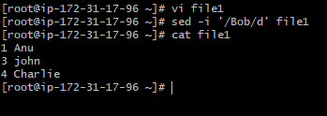

Append or insert text before or after a specific pattern or line.

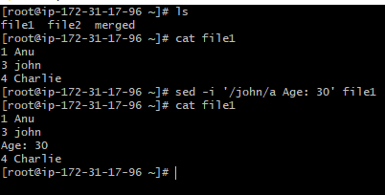

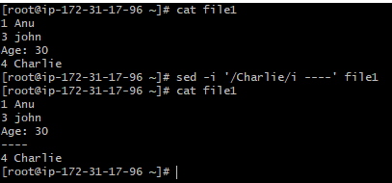

40) Print only specific lines from a file.

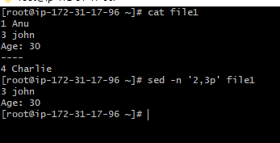

Copy file from linux to windows machine

